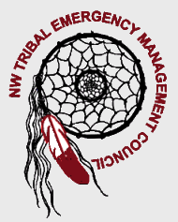
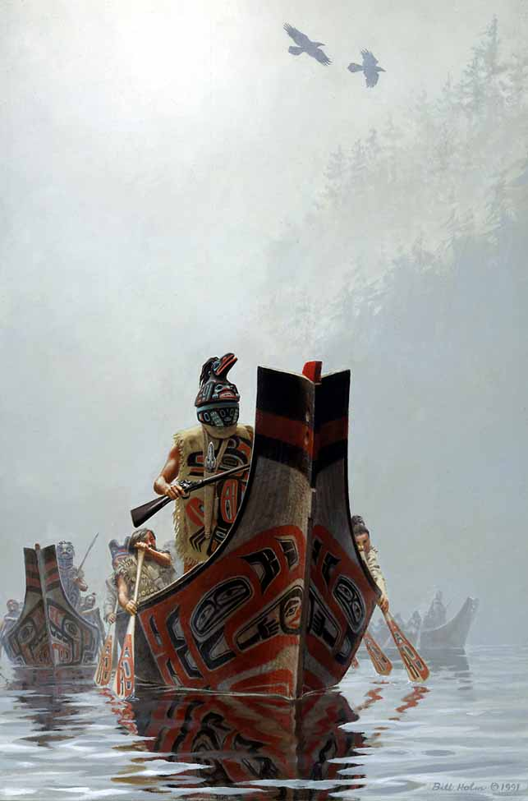

Region I Homeland Security
Tribal Committee
www.nwtemc.org

February 21, 2008
10:00 AM-1:00 PM
Location is at the Tulalip Casino, Cabaret Room, Quilceda, WA 98271
********************************************************************************************
Meeting Called By: Lynda Harvey, Chairperson NWTEMC
Introductions:
NWTEMC Sign-in
Colville Tribes | Claude Cox | 509.634.2448 | claude.cox@colvilletribes.com
Lummi | Rolan Cobery | 360.384.2256 | rolanc@lummi-nsn.gov
Lummi | Rance Sutton | 360.384.2266 | rances@lummi-nsn.gov
Lummi | Wendy Woods | 360.384.2245 | wenyw@lummi-nsn.gov
Lummi | Gary James | 360.384.0945 | garyj@lummi-nsn.gov
Nooksack | Jim Fernando | 360.319.9056 | jfernando@nooksack-tribe.org
Nooksack | Dana Harkins | 360.966.2106 | Danahar98@yahoo.com
NWTEMC | Glenn Coil | 360.651.3294 | gbcoil@nwtemc.org
NWTEMC | Lynda Harvey | 360.651.3295 | Blockwtch1@aol.com
Samish | Keith Tucker | 360.299.6404 | ktucker@samishtribe.nsn.us
Sauk-Suiattle | Owen Couch | 360.435.0438 | policechief@sauk-suiattle.com
Shoalwater Bay Tribe | Lee Shipman | 360.267.8120 | leshipman@sholawaterbay-nsn.gov
Snoqualmie | Fuzzy Fletcher | 206.390.4136 | fuzzy@snoqualmienation.com
Stillaguamish | Steve Hardy | 425.508.1467 | shardy@stillaguamish.nsn.gov
Swinomish | Jim Sande | 360.466.7227 | jsande@swinomish.nsn.us
Tulalip Tribes | Bill Williams | 360.651.4608 | wwilliams@tualiptribalpolice.org
Upper Skagit PD | Paul Budrow | 360.661.1544 | paulb@upperskagit.com
Upper Skagit Tribe | Joe Hemmerich | 360.854.7054 | joeh@upperskagit.com
WA State EMD | Dave Nelson | 253.512.7075 | d.nelson@emd.wa.gov
WA State EMD | George Crawford | 253.512.7067 | g.crawford@emd.wa.gov

Agenda Topics:

- WA Tsunami Representatives
  - George Crawford and Dave Nelson
- Elections Announcements
  - Chair/Vice Chair/Secretary
- Recruitment of Additional Members
- Conference Calling- Chief Budrow
- Legislation Update
- State Emergency Response Commission: January 25th, 2008 Meeting
- DOH Grants/EMPG Grants/Emergency Fuel
- Web Site Updates
- Hospital/ Statewide EOC
- Training Opportunities

Minutes:

- State Tsunami Workgroup – Try to get a Tribal person to sit at the national level. State meeting quarterly, national meeting once to twice a year.

Vote to allow Dave Nelson/George Crawford as Tribal Reps: Unanimous in favor

- NWTEMC Recruitment:
  - Send formal letter. Great 8 Calendar
  - Emphasis: NIMS Compliance. Programs such as CERT Training, Medical Reserve Corps, Incident Command System
- E-mail powerpoint for review
- Research Mobile Conference Calling
- SERC representation issues

